

VistA Imaging System

– Revision

Department of Veterans Affairs

Office of Enterprise Development

Health Provider Systems

**VistA Imaging****March 2013**

**Property of the US Government**

This is a controlled document. No changes to this document may be made without the express written consent of the VistA Imaging Office of Enterprise Development group.

While every effort has been made to assure the accuracy of the information provided, this document may include technical inaccuracies and/or typographical errors. Changes are periodically made to the information herein and incorporated into new editions of this document.

Product names mentioned in this document may be trademarks or registered trademarks of their respective companies, and are hereby acknowledged.

VistA Imaging Office of Enterprise Development  
Department of Veterans Affairs  
Internet: <http://www.va.gov/imaging>  
VA intranet: <http://vaww.va.gov/imaging>

**Revision History**

| **Date** | **Rev** | **Notes** |
| --- | --- | --- |
| Mar 2013 | 1.1 | Minor updates from feedback received H.Suri |
| Dec 2012 | 1.0 | Initial draft; H.Suri |

Contents

Preface iv

Terms of Use iv

Conventions v

Related Information vi

Getting Help vi

AWIV Web Application Overview 1

How the AWIV Web Application Works 1

AWIV Implementation from the AWIV Web Application 1

AWIV Web Application Main Window 2

How the AWIV Web Application Handles Images 3

Logging in to the AWIV Web Application 5

Using the AWIV Web Application 7

Displaying Available Patient Images 9

Searching for a Patient 9

Selecting a Patient 10

Patient Information 11

Connecting to a Site 12

Disconnecting from a Site 12

Displaying Patient Images 12

Selecting a Different Patient 13

Image List Information 15

Image List 15

Image Status Icons 15

Sorting the Image List 16

Hiding/ Displaying Columns in the Image List 17

Auto Fit / Auto Fit All Columns 17

Auto Fit 17

Auto Fit All Columns 17

Displaying an Image Report 18

Displaying Image Information 18

Displaying Advanced Image Information 19

Opening an Image 20

Closing the AWIV Web Application 21

Troubleshooting 23

AWIV Not Installed 23

Partial Results 23

About the AWIV 24

Message log 24

Terms and Acronyms 25

# Preface

This manual describes the VistA Imaging AWIV Web Application. It is intended for clinicians who need access to patient images. This manual assumes that a current version of the AWIV component is installed and that users are familiar the Microsoft Windows environment. This manual only contains instructions on using the AWIV Web Application. For instructions on using the AWIV component, refer to the *VistA Imaging AWIV User Guide*.

## Terms of Use

The is a component of VistA Imaging and is regulated as a medical device by the Food and Drug Administration (FDA). Use of is subject to the following provisions:

|  |  |
| --- | --- |
| Warning icon | Caution: Federal law restricts this device to use by or on the order of either a licensed practitioner or persons lawfully engaged in the manufacture or distribution of the product. |
| Warning icon | The FDA classifies VistA Imaging, and the (as a component of VistA Imaging) as a medical device. Unauthorized modifications to VistA Imaging, such as the installation of unapproved software, will adulterate the medical device. The use of an adulterated medical device violates US federal law (21CFR820). |
| Warning icon | Because software distribution/inventory management tools can install inappropriate or unapproved software without a local administrator’s knowledge, sites must exclude the from such systems. |

## Conventions

This document uses the following conventions:

| Symbol/Typeface | Meaning/Use | Example |
| --- | --- | --- |
| **Warning icon** | Indicates critical information. |  |
| Tip | Indicates useful or supplementary information |  |
| NOTE | Indicates important or required information is shown |  |
| **Bold** | User input, selection, GUI element (menu item, button, field) | Click **Finish**.  Choose **Open** from the **File** menu.  Type the user account name in the **Name** field. |
| **File | Open** | A vertical bar is used to separate menu choices. | For example: “Click **File | Open**” means: “Click the **File** menu, then click the **Open** option.” |
| Monospaced **font (typically in a box)**  **(Bold** **indicates user input or selection).** | Command-line sample or output (such as character-based screen captures and computer source code), menus, file names | Navigate to the \Docs\Imaging_Docs_Latest folder. |
| Italics | Emphasis, reference to section in the document or another document, or a variable | For more information, see the VistA Imaging DICOM Gateway Installation Guide.  MAG*3.0*124.KID |
| **UPPERCASE** | **M code, variable names, or the formal name of options, field/file names, and security keys.** | **The XUPROGMODE key** |
| **Hyperlinks** | **Hyperlinks are indicated in blue underline.** | <http://www.va.gov/vdl/application.asp?appid=105> |
| **[CTRL]** | Keyboard key names are shown in bold and in brackets |  |

## Related Information

Additional information about VistA Imaging and VistAWeb can be found at:

* VistAWeb: <http://www.va.gov/vdl/application.asp?appid=147>
* VistA Imaging: <http://www.va.gov/vdl/application.asp?appid=105>

## Getting Help

If you encounter any problems using the AWIV Web Application, contact your local Imaging Coordinator or support staff. If the problem cannot be resolved locally, use Remedy to place a service request, or contact the National Help Desk at 1‑888‑596‑4357.

# AWIV Web Application Overview

## How the AWIV Web Application Works

The VistA Imaging Advanced Web Image Viewer (AWIV) Web Application provides a way for clinicians to view images using VA approved versions of Microsoft Internet Explorer (IE), similar to the way that VistAWeb currently does.

The AWIV Web Application is hosted on the Centralized VistA Imaging eXchange (CVIX). The AWIV Web Application retrieves patient images from VistA and allows users to view all available patient images using the AWIV component. Previously users were able to view patient images through VistAWeb and the AWIV component. The AWIV Web Application allows users to access all patient images available in VistA Imaging as well as DoD images, whereas not all patient images are available using VistAWeb.

**NOTE:** The AWIV Web Application is a browser-based application that provides a subset of the features of Clinical Display. Certain Clinical Display features (such as filters) and image types (such as EKG images stored on MUSE servers) are not available in the AWIV component and are only available in Clinical Display.

## AWIV Implementation from the AWIV Web Application

When a user signs into the AWIV Web Application, their credentials are authenticated against the selected VistA databases and patient sensitivity checks are performed.   The AWIV Web Application then displays the welcome message from the authenticating VistA system.

When the AWIV Web Application launches the AWIV component, it passes image identifiers for the images to be displayed to the AWIV.  The AWIV component in turn uses those parameters to locate remotely stored images via the CVIX service. The CVIX, on receiving image requests from the AWIV component, pulls the images from the applicable remote VA site or DoD and passes them back to the AWIV component. The CVIX caches images that it handles to speed any subsequent requests for the same images.

**NOTE:** The AWIV Web Application passes patient information and user credentials to the AWIV component upon every request to display images.

## AWIV Web Application Main Window

The image below shows the main AWIV Web Application window and the various components of this window.

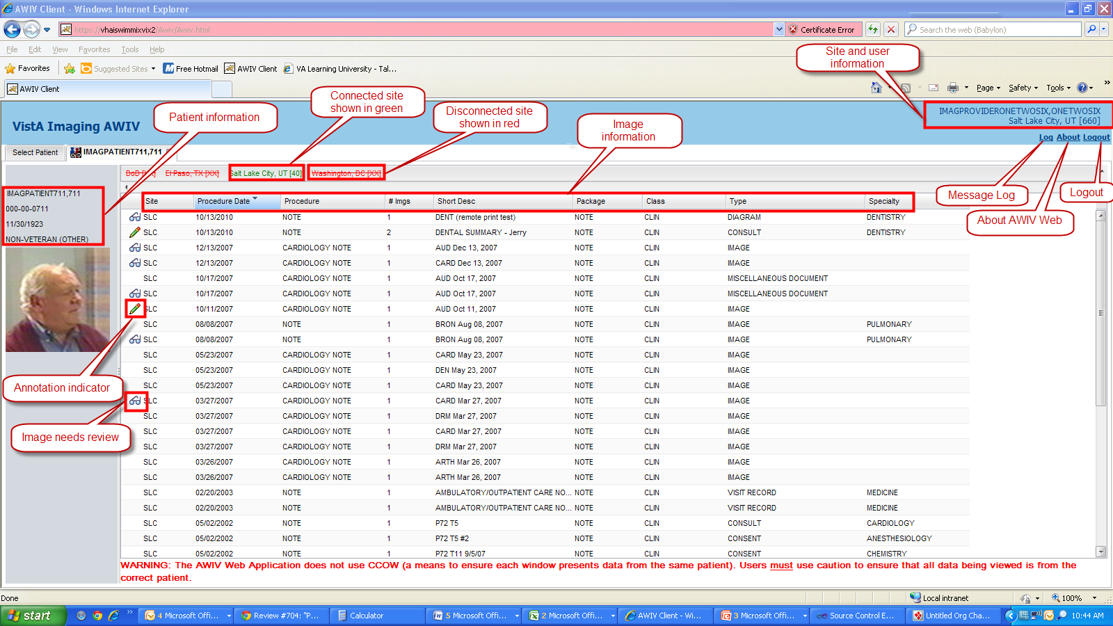

The main AWIV Web Application window contains image information, patient and site information, connected and disconnected sites.

The AWIV Web Application allows users to view and manipulate patient images from the VA VistA Imaging using the AWIV component, which previously, was only available using VistAWeb. The AWIV Web Application also allows users to access patient data from the Department of Defense (DoD).

**NOTE:** The AWIV only lists the sites where the patient has been seen and not all available VA sites.

## How the AWIV Web Application Handles Images

When you double-click a study displayed in the AWIV Web Application, the AWIV component window opens with all available image abstracts (of the selected study) in the abstracts area on the left of the AWIV component window. You can then load an image in the main image viewer window by clicking that image’s abstract.  The AWIV Web Application passes the image information to the AWIV component and the AWIV component retrieves and displays the image associated with the selected abstract in the main image viewer window.

**NOTE**: When you select a DoD artifact, the AWIV component window opens with all image abstracts automatically loaded in the abstracts area, and the first image is automatically opened in the main AWIV component viewer or in an external viewer (depending on the image type).

This page is intentionally blank.

# Logging in to the AWIV Web Application

To log in to the AWIV Web Application, follow these steps

1. Go to the URL <https://vhacvixclu2.r04.med.va.gov/Awiv/> using a VA approved version of Microsoft Internet Explorer.

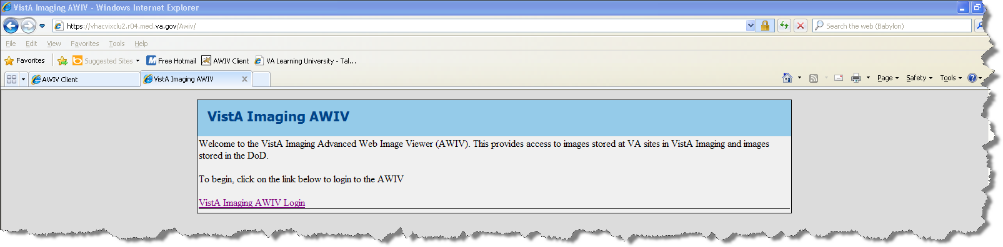

1. Click VistA Imaging AWIV Login.
2. Select the site at which you have credentials to login and click OK.
3. When you see the site welcome message, enter your Access and Verify codes at the bottom of the VistA Imaging AWIV – Login screen and click OK.

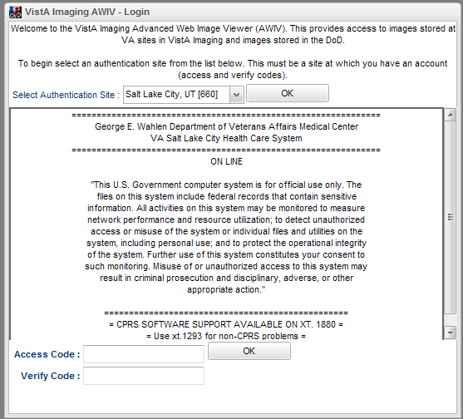

This page is intentionally blank.

# Using the AWIV Web Application

To access patient images using the AWIV Web Application follow these steps:

1. Follow steps in the previous section to login to the AWIV Web Application.
2. When the main AWIV Web Application window opens, search for a patient using the search box.
3. From the list of displayed matches, select the desired patient by double-clicking the patient. The selected patient in a new tab
4. Click one or more site(s) that the patient has been seen at in the site information bar, to display studies from that site(s).
5. Double-click a study to open images in the AWIV component.
6. Review and manipulate images as needed, using the AWIV component.

For more details on how to use the VistA Imaging AWIV component to display and manipulate images, refer to the *AWIV User Guide*.

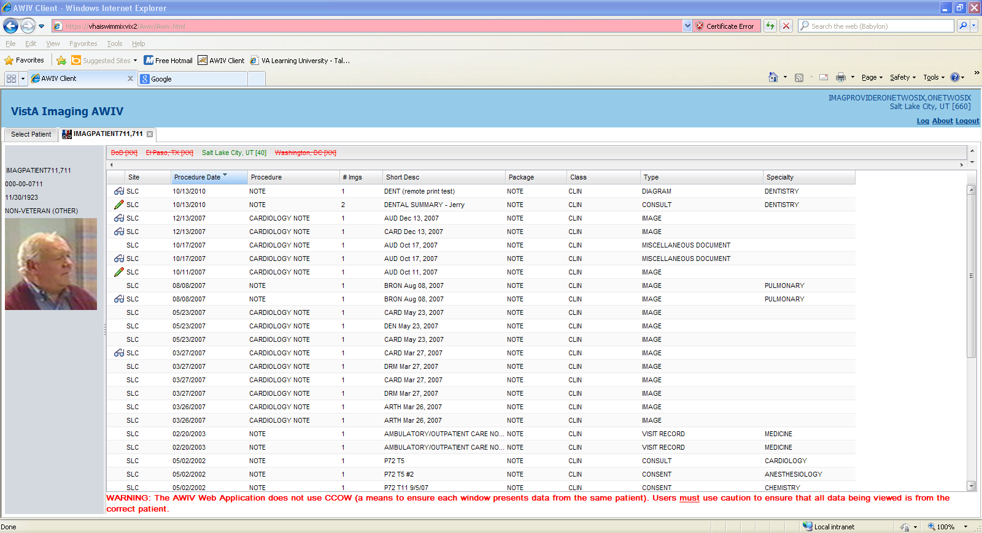

**NOTE:** If you try to access images using any other browser except VA approved versions of Microsoft Internet Explorer (IE), the AWIV Web Application will display a warning message indicating that the patient images are not viewable through the AWIV component.

This page is intentionally blank.

# Displaying Available Patient Images

To display patient images, follow these steps (see detailed instructions in sections below):

1. Search for a patient.
2. Select a patient.
3. Connect to a site.
4. Double-click a study to open available images in the AWIV component window.

**NOTE:** The AWIV component must be installed in order to view and manipulate images. If the AWIV component is not installed, the AWIV Web Application displays an error message indicating that the AWIV component is required to view images but is not installed.

## Searching for a Patient

When you login to the AWIV Web Application, the patient search screen is displayed where you can search for a patient.

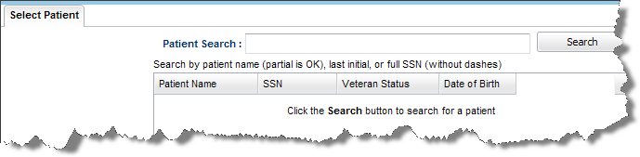

You can search for a patient by name or Social Security Number (SSN).

Enter your search criteria in the box labeled **Patient Search** and click **Search.**

**NOTE:** You can also search using a partial patient name or last initial, last four digits of SSN similar to patient search in the VistA System.

## Selecting a Patient

When you search for a patient, a list of patients that match the search criteria is displayed in a grid with Patient Name, SSN, Veteran Status and DOB as shown in the image below.

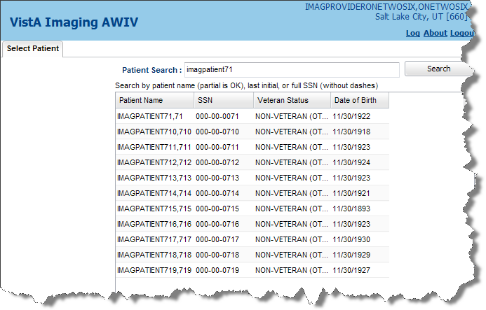

If a patient photo ID is available for the selected patient, it is displayed along with the patient name on the left side of the screen. See image below. From the list of patients displayed, select the required patient by double-clicking the patient’s name.

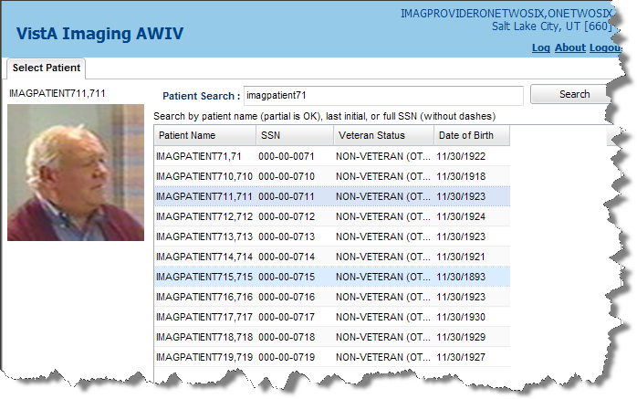

Doing so opens a new tab in the AWIV Web Application with the selected patient information.

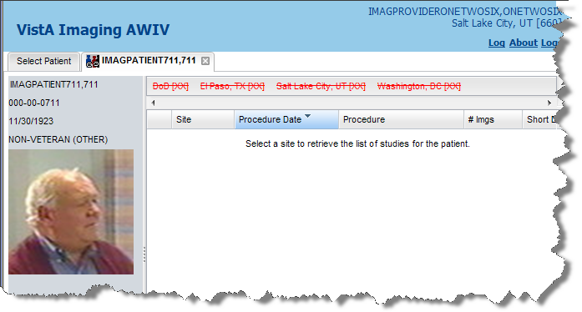

|  |  |
| --- | --- |
| Warning icon | WARNING:The AWIV Web Application does not use Clinical Context Object Workgroup (CCOW) CCOW keeps patient context synchronized between VistA Imaging Applications and other VistA applications such as CPRS. Make sure that all data you view is from the correct patient. |

## Patient Information

The patient window contains patient information on the left side of the main AWIV Web Application window as shown below:

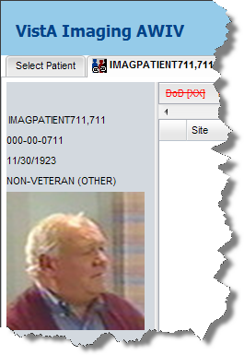

The patient information displayed includes:

Patient name, Social Security Number (SSN), Date of Birth (DOB) and patient’s Veteran Status.

## Connecting to a Site

When the patient information is first displayed, the Site Information bar (above the Image information bar) will display the site(s) where the patient has been seen. This is a list of sites where the patient has been seen in the VA and might also include the DoD.



The site names will appear in Red letters with the site name struck-through as displayed below:

Information bar displays sites where patient has been seen.

You can connect to a site where the patient has been seen by clicking on one of the available sites. Once you connect to the site, the site name connected to will be displayed in **Green** letters along with the number of studies at that site in parenthesis as shown below:

Click on a site name to connect to the site

NOTE**:** If more than one site is available for the selected patient, you will have to click each site name to connect to it and display patient images from that site.

## Disconnecting from a Site

To disconnect from a site and to not display the patient images from that site, click the site name shown in **Green**. The site name turns back to ~~Red~~ strikethrough font, indicating that you are disconnected from that site.

## Displaying Patient Images

To display patient images from an available study, double-click the study to open the AWIV component window. The AWIV component window will contain all available abstracts from the selected study in the Abstracts area on the left of the window. Click any abstract to load the corresponding image in the main image viewer area of the AWIV component window. For more details on how to use the VistA Imaging AWIV component to display and manipulate images, refer to the *AWIV User Guide*.

## Selecting a Different Patient

To select a different patient, click the **Select Patient** tab to the left of the selected patient information tab from the AWIV Web Application window.

**NOTE:** The tab with the previously selected patient information is automatically closed when you select a new patient from the **Select Patient** tab.

**NOTE:** The AWIV component window closes automatically when a different patient is selected in the AWIV Web Application.

For more details on how to use the VistA Imaging AWIV component to display and manipulate images, refer to the *AWIV User Guide*.

This page is intentionally blank.

# Image List Information

## Image List

The AWIV Web Application displays all available images in a grid from the selected site as shown below:

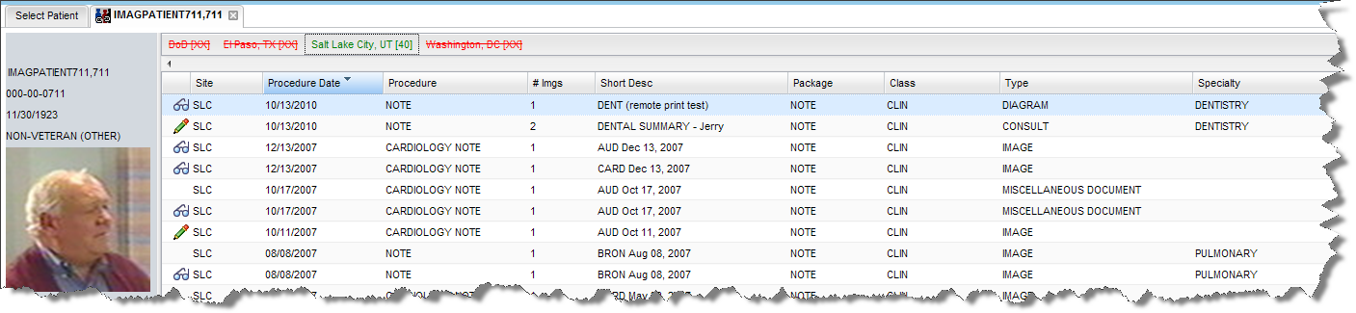

The image information displayed includes these columns:

* + Site
  + Procedure date
  + Procedure
  + Number of images in study
  + Short Description
  + Package
  + Class
  + Type
  + Specialty

## Image Status Icons

The AWIV Web Application displays image status icons in the Image List based on available study/ image information.

|  |  |
| --- | --- |
| Needs Review icon | Indicates that images in the study have a status of ‘Needs Review’. |
| Annotations available icon | Indicates that Annotations are available for images in the selected study. |
| Images in study in progress icon | Indicates the images in the study are in progress. |
| Images may have questionable integrity icon | Indicates the images in the study have questionable integrity. |
| Image blocked bny TIU rule icon | Indicates the study is blocked by a TIU business rule. |
| Study is blocked by RAD exam status | Indicates the study is blocked by a RAD exam status. |
| Sensitive study icon | Indicates the study is sensitive. |

NOTE**:** Annotations are not displayed in the AWIV Web Application or the AWIV component. Only an Annotation Indicator is displayed in the AWIV Web Application and the AWIV component window. To view the actual annotations, you must log in to VistA Imaging Clinical Display.

## Sorting the Image List

You can sort the image list displayed in the main AWIV Web Application window by any of the columns available. There are two ways to sort the image list:

* Clicking the column name displays an arrow pointing either up or down, which indicates the sort order. Up arrow indicates that the list is sorted in ascending order and down arrow indicates that the list is sorted in descending order. Click the column name once to sort the list in ascending order and click the column name again to sort in descending order. See sample images and explanation below:

Image list sortedt in ascending order by procedure date  Indicates that the image list is sorted by procedure date in descending order.

Image list sortedt in descending order by procedure date  Indicates that the image list is sorted by procedure date in ascending order.

* Clicking the down arrow next to the column name gives you more sort options. You can choose **Sort Ascending** or **Sort Descending** from the additional options displayed.

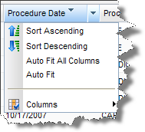

## Hiding/ Displaying Columns in the Image List

You can choose the columns to display in the image list. To do this, click the down arrow next to any column name and highlight **Columns** to open additional options. Then click the columns you would like to hide, which will show them de-selected. Column names that are set to display will have the check mark next to them. See image below.

NOTE**:** All columns are displayed by default and they will appear with check marks by default as shown below.

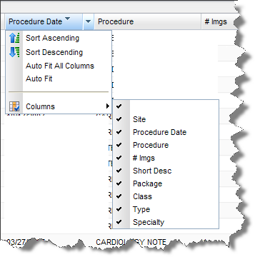

## Auto Fit / Auto Fit All Columns

### Auto Fit

You can choose the **Auto Fit** option to resize a specific column to the size of the text in the column.

### Auto Fit All Columns

You can choose the **Auto Fit All Columns** option to resize all the columns to the size of the text in the columns.



## Displaying an Image Report

To display a report associated with an image from within the AWIV Web Application, follow these steps:

1. Right-click the study containing the image. Doing so brings up a menu with options as shown below.

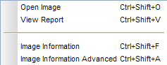

1. From this menu, select **View Report** to display the report associated with the selected image to display the report as shown below.

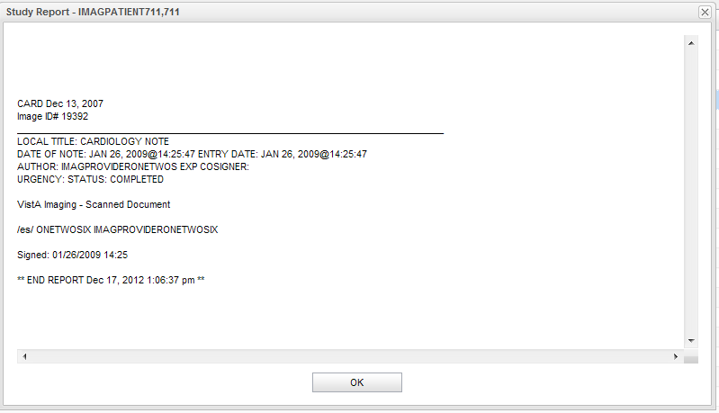

1. Click **OK** to return to the Image List.

## Displaying Image Information

To view image information from within the AWIV Web Application, follow these steps:

1. Right-click the study containing the image and select Image Information. 
2. The Image information is displayed in a separate window on top of the Image List window as shown below.

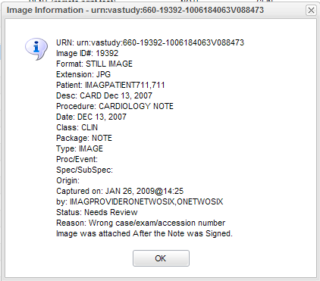

1. Click **OK** to return to the Image List.

## Displaying Advanced Image Information

1. To view image information from within the AWIV Web Application, right-click the study containing the image and select Image Information Advanced. 

The Image information is displayed in a separate window on top of the Image List window as shown below.

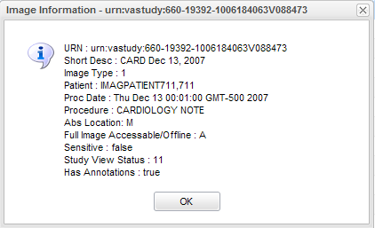

1. Click **OK** to return to the Image List.

NOTE**:** This option is available only to users with the MAG SYSTEM security key.

## Opening an Image

To open an image from within the AWIV Web Application, right-click the study containing the image and select **Open Image**.



You can also open an image by double-clicking it from the Image List in the AWIV Web Application.

# Closing the AWIV Web Application

To close the AWIV Web Application window, click Logout button in the upper right hand corner of the AWIV Web Application window or click X Button at the top right corner of the browser window to close the browser.

NOTE: The AWIV component window will close automatically when a different patient is selected in AWIV Web Application.

This page is intentionally blank.

# Troubleshooting

## AWIV Not Installed

The AWIV component must be installed in order to view and manipulate images. If the AWIV component is not installed, the AWIV Web Application displays an error message indicating that the AWIV component is required to view images but is not installed. See image below.

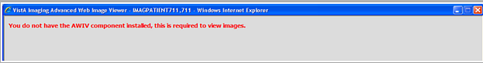

## Partial Results

The AWIV Web Application will alert you if a partial results flag is included in the list of documents or radiology images retrieved from one (or both) of the following DoD data sources:

* BHIE (Bidirectional Health Information Exchange) or
* BIA (BHIE Image Adapter or Bidirectional Health Information Exchange Image Adapter)

Either BHIE or the BIA (or both) can return a partial result.  If a partial result is returned to the client, the AWIV Web Application will display a message (in the site information bar) indicating the data from the DoD is a partial result and there might be more data available.

If this happens, you may try to refresh the image list by Disconnecting and reconnecting to the site. To do this, click the **DoD** link in the site information bar once to disconnect and click again to connect.

## About the AWIV

To display version information about the AWIV Web Application, click the **About** About button link located in the upper right corner of the AWIV Web Application window. A window with the AWIV version information is displayed as shown below.

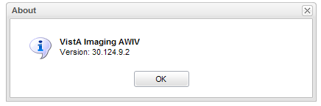

## Message log

The Message Log is used to view system messages for debugging purposes. Click **Log Log button** in the upper right corner of the AWIV Web Application window to view message history in a separate tab as shown in the image below.

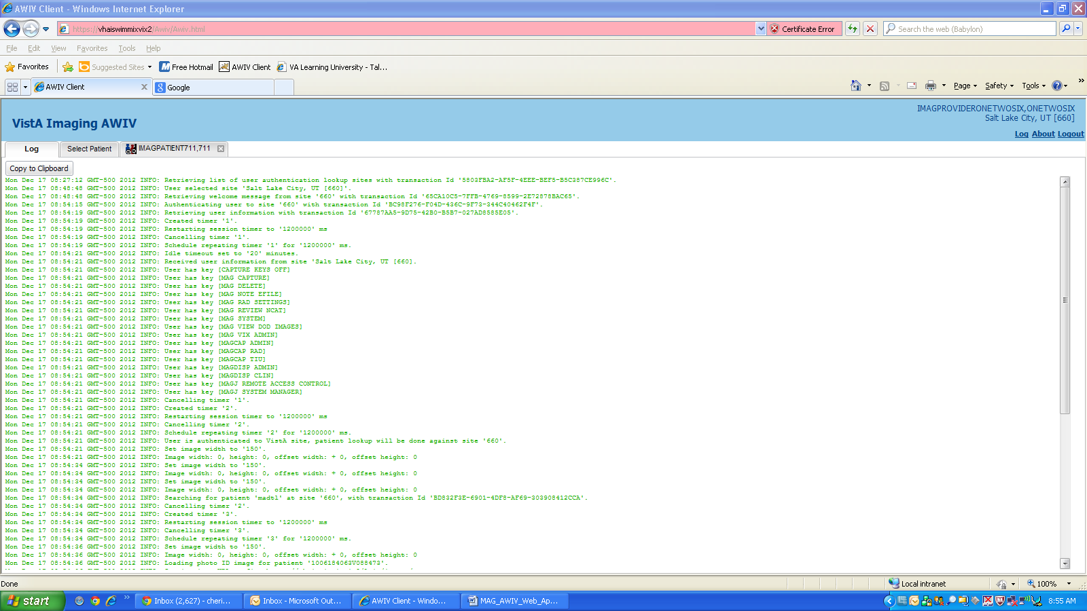

Click **Copy to Clipboard Copy to Clipboard button** to view the text in a dialog that can be copied to the clipboard. To exit the message log tab, click **Log** in the top right corner of the main AWIV Web Application window again.

# Terms and Acronyms

| **Acronym /Term** | **Definition** |
| --- | --- |
| AWIV component | Advanced Web Image Viewer component |
| BHIE | Bidirectional Health Information Exchange |
| BIA | BHIE Image Adapter or Bidirectional Health Information Exchange Image Adapter |
| CCOW | Clinical Context Object Workgroup. CCOW keeps patient context synchronized between VistA Imaging Applications and other VistA applications such as CPRS. |
| CPRS | Computerized Patient Record System |
| CVIX | Centralized VistA Imaging eXchange |
| DFN | Data File Number |
| DOB | Date of Birth |
| DoD | Department of Defense |
| EKG | Electrocardiogram |
| FDA | Food and Drug Administration |
| HAIMS | Healthcare Artifact and Image Management Solution which is the DoD’s health information system. |
| ID | Identifier or Identification |
| MUSE | A third party cardiology information system used to store and manage ECG/EKG (electrocardiogram) images. If a VA facility stores their ECG images in MUSE, they will not be accessible to the AWIV component. |
| NCAT | Neuro-Cognitive Assessment Tool |
| SSN | Social Security Number |
| VA | Veteran Affairs |
| VistA | Veterans Health Information System and Technology Architecture |
| VistAWeb | VistAWeb is an intranet web application used to review remote stored VistA and Health Data Repository (HDR) patient information; see <http://vista.med.va.gov/vistaweb/index.htm> for details about VistAWeb |